**COVID 19**

TEAM NAME: BIRA VIRUS

TEAM LEADER: SHREYANSH SATVIK

TEAM LEADER EMAIL: [shreyansh.satvik2018@vitstudent.ac.in](mailto:shreyansh.satvik2018@vitstudent.ac.in)

Website:

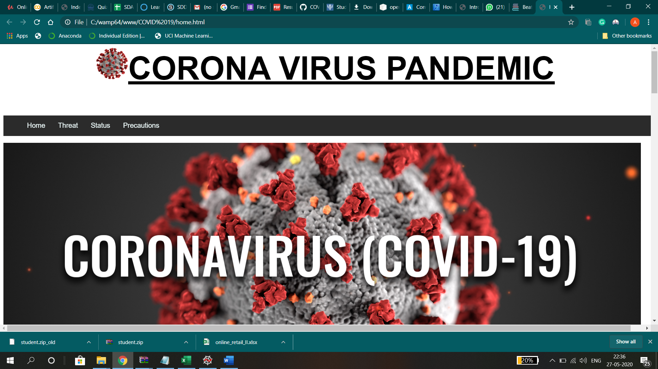

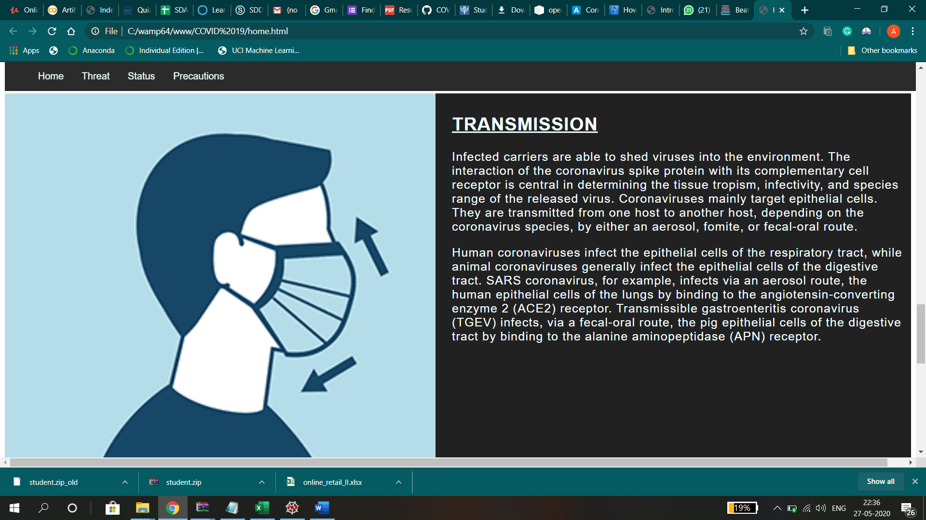

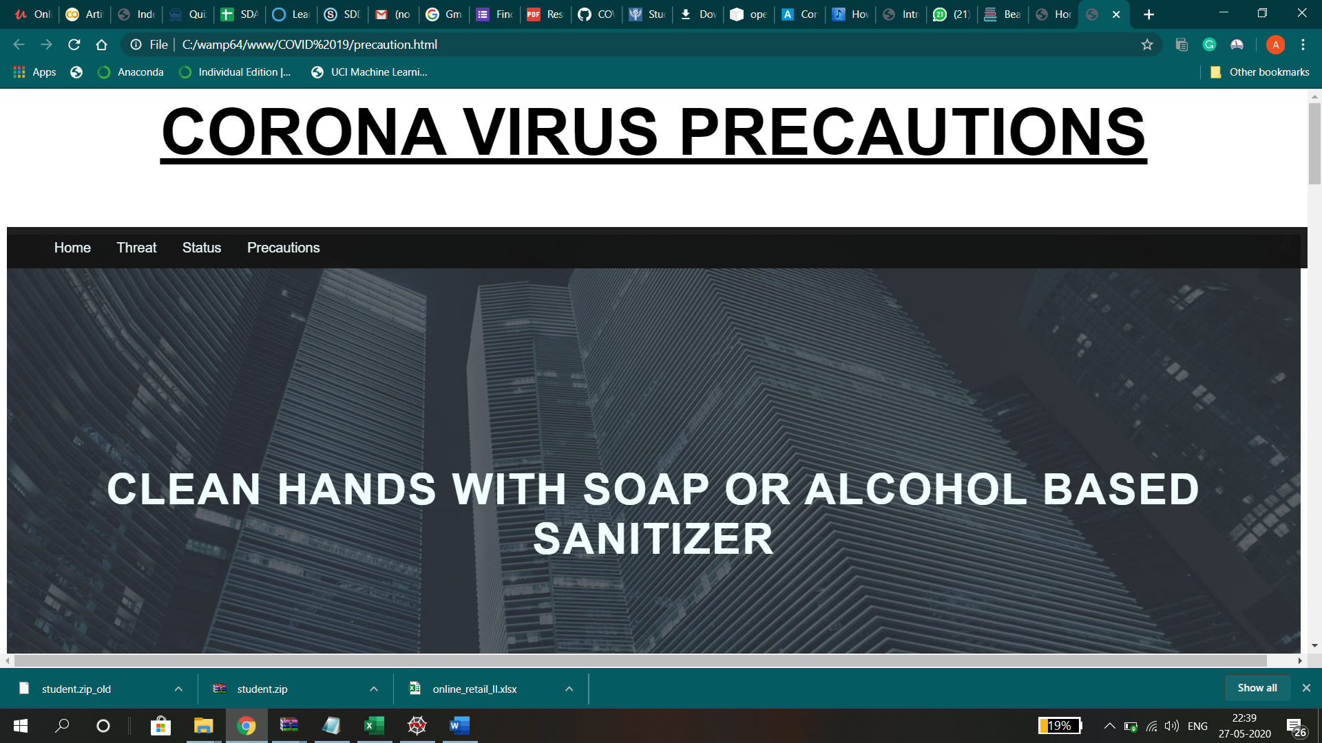



Facemask output:

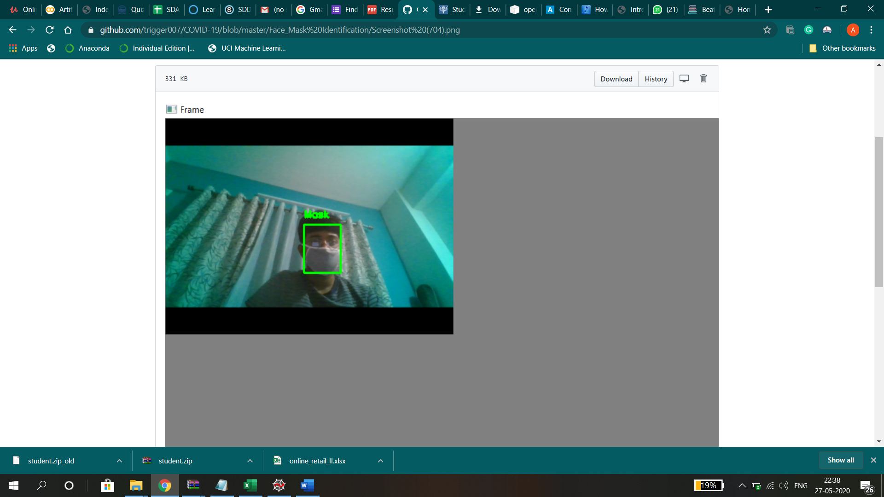

Covid 19 cases prediction:

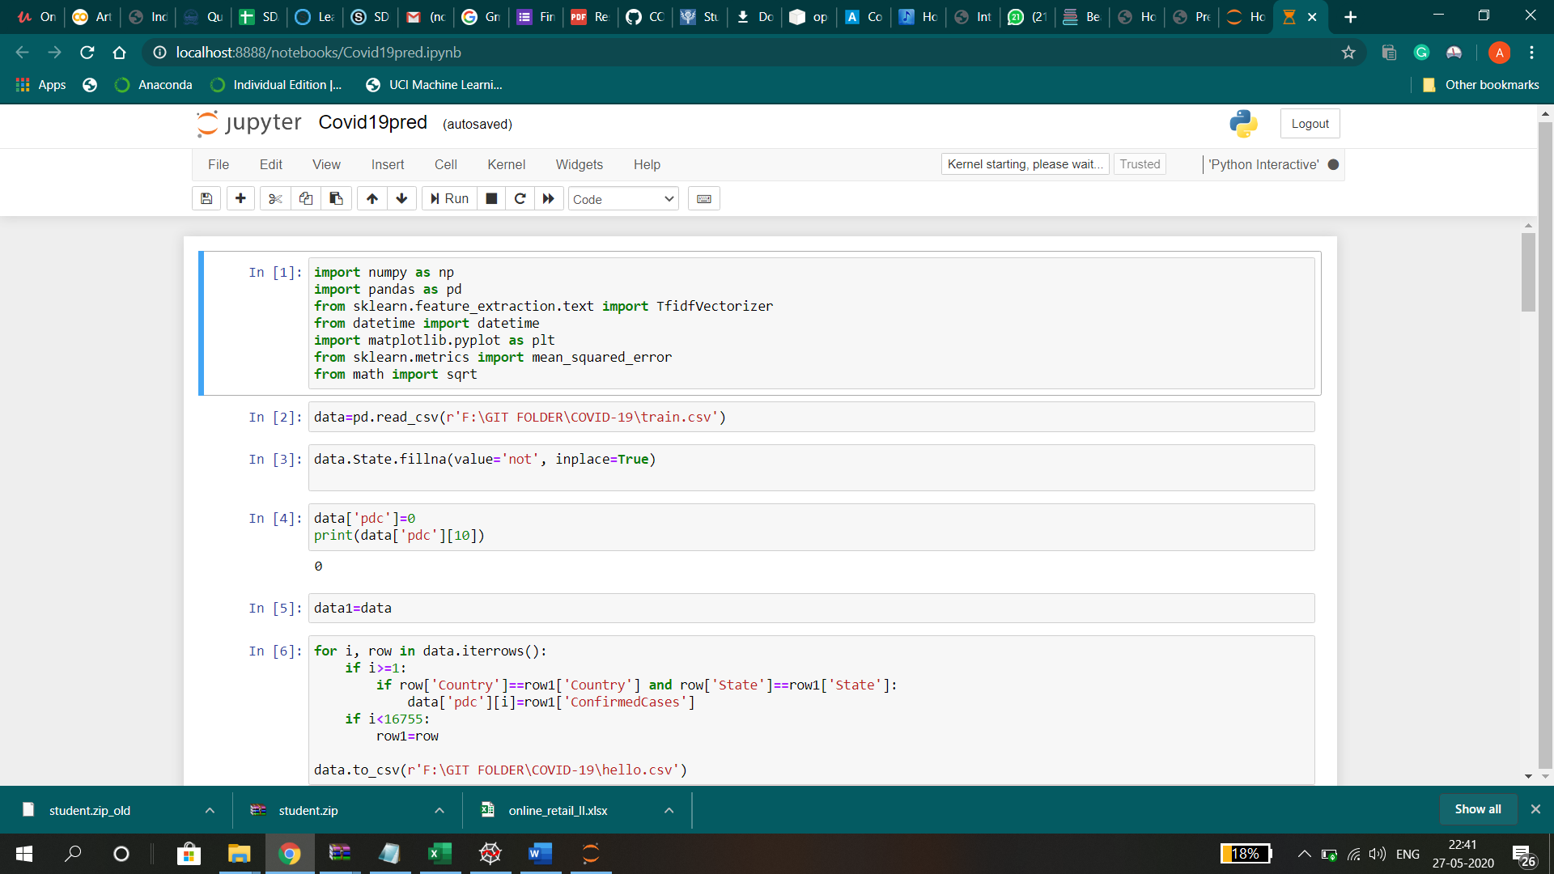

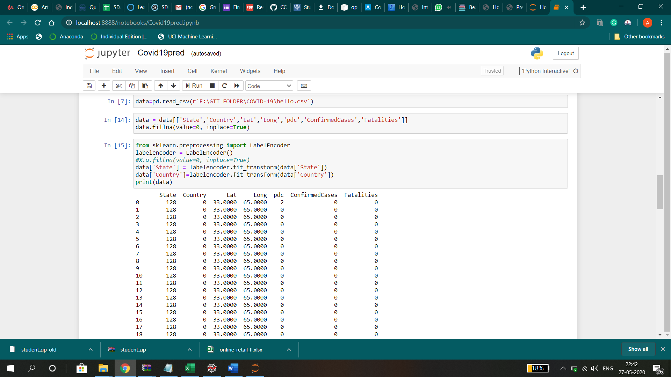

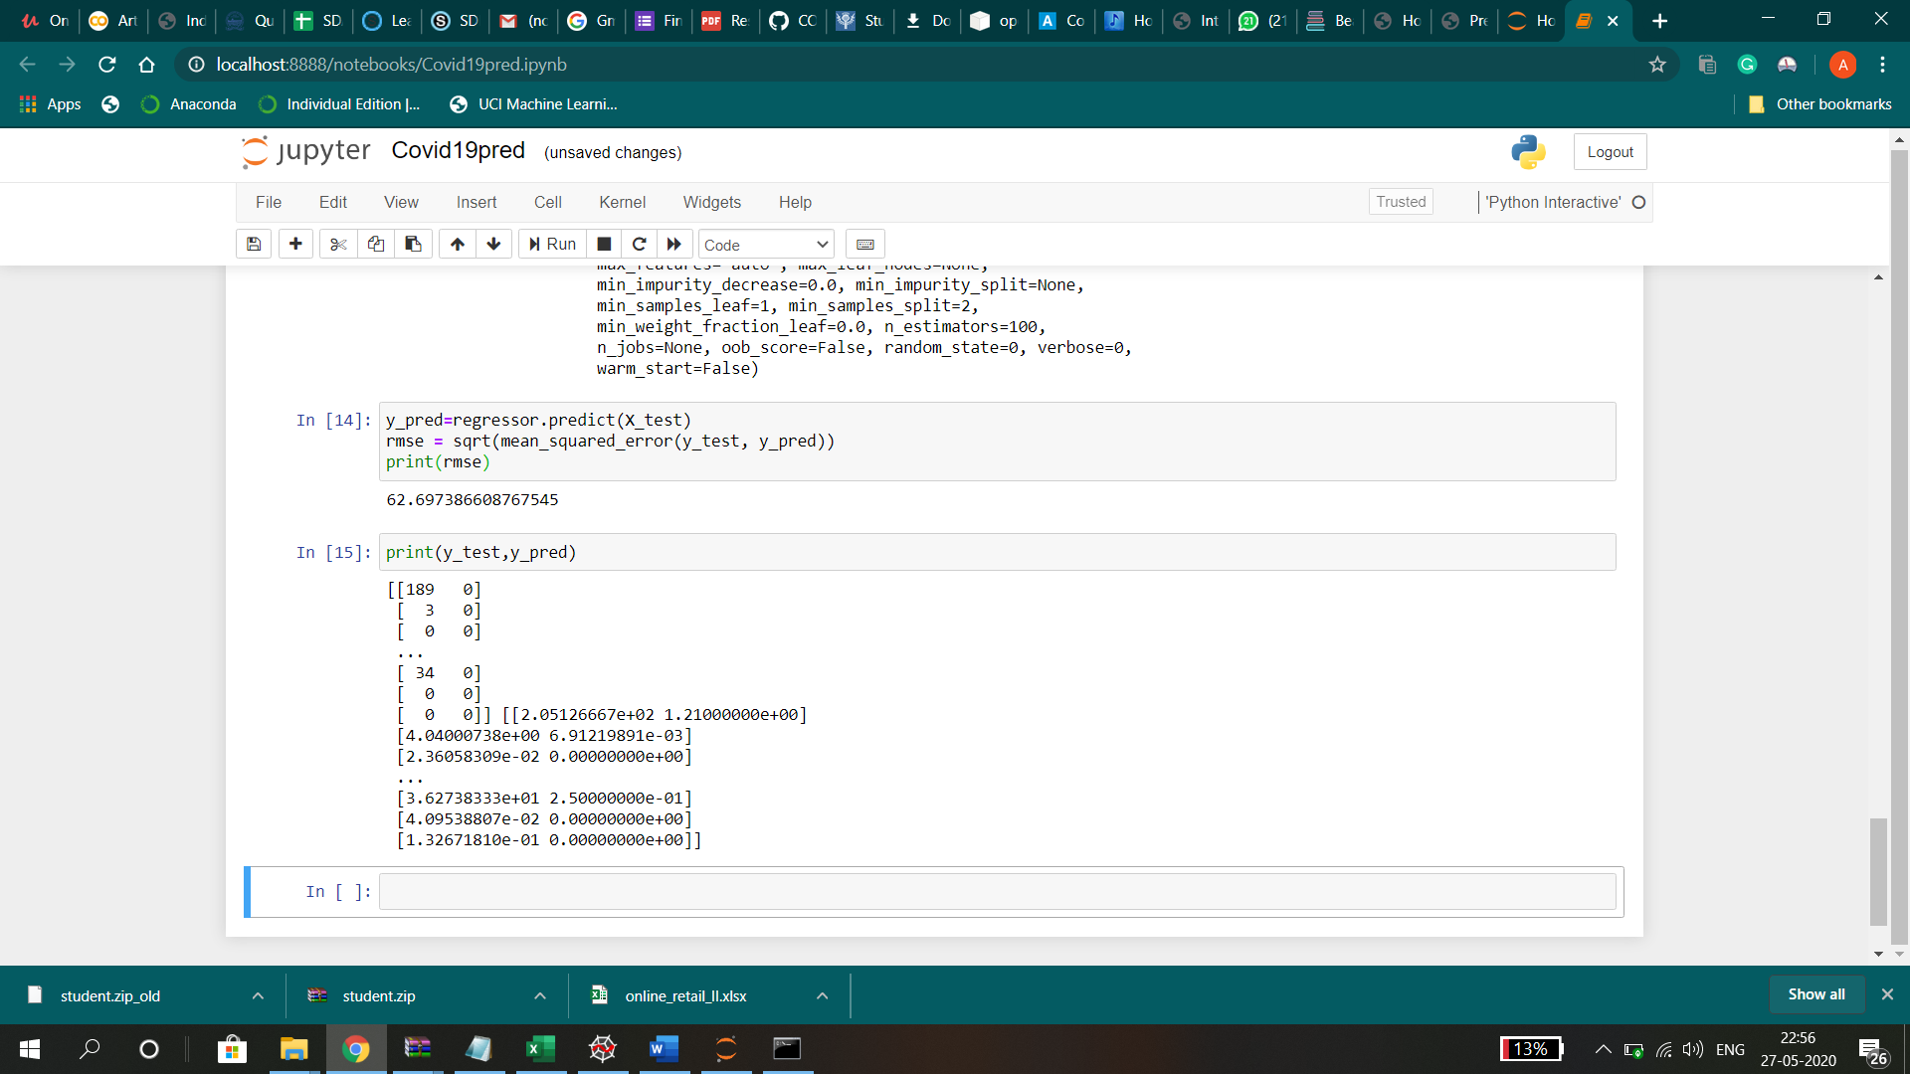

GITHUB LINK: <https://github.com/trigger007/COVID-19>